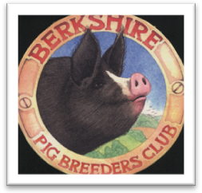The Berkshire Pig Breeders Club
Standing Order Mandate

TO ___________________________________________________________________________________BANK (where your account is)
POSTAL ADDRESS………………………………………………………………………………………………………………………………………….
…………………………………………………………………………. POSTCODE……………………………
PLEASE PAY
BANK | BRANCH TITLE | SORT CODE
LLOYDS TSB | CLITHEROE BRANCH | 77-76-01

FOR BENEFICIARY NAME | ACCOUNT NUMBER |  |  |  |  |  |  |  | REFERENCE
THE BERKSHIRE PIG BREEDERS CLUB | 1 | 9 | 5 | 7 | 3 | 0 | 6 | 8 | (Your details for us to identify your payment)
AMOUNT
Please delete as appropriate  £20 SINGLE MEMBERSHIP  OR  £25 FAMILY MEMBERSHIP | DATE OF FIRST PAYMENT  ______________________(insert date)  THEREAFTER ON THE 1ST OF JANUARY ANNUALLY UNTIL FURTHER NOTICE

NAME OF ACCOUNT TO BE DEBITED | ACCOUNT NUMBER |  |  |  |  |  |  |  | SORT CODE

DATE …………………………. SIGNATURE ………………………………
ADDRESS………………………………………………………………………………………………………………………………………………………
……………………………………………………………………………………………………………………………………………………………………
PHONE NUMBER ________________________________________________
EMAIL ADDRESS _________________________________________________________________________________________

